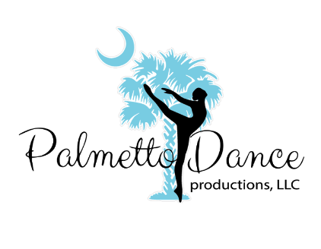
January Newsletter
An invitational to join Remind.com will be sent out. This will allow the faculty faster communication with you about any future updates.
Be reminded all tuition is due by the 10th of each month

Welcome Back Dancers and Happy New Year!
Important information:
Classes will resume the week of January 4th. We are so excited be back at dance to start working on the 2021 recital. January to June is usually over in a blink and we encourage parents to read the monthly newsletters so you do not miss anything.
Also, remember attendance is critically important in the next few months.
Please read through the COVID-19 safety protocols below that will be implemented starting the week of January 4th.
Street Shoes are not allowed to be worn on the new dance flooring that has been laid. If you need to use the restroom your shoes will need to be removed before crossing the floor. Tennis shoes for hip hop will need to be wiped down before entering studio.
Costume deposit invoices for recreational classes will be sent out this month. Remember the deposit for costumes is due by January 29th.
Deposits are $50 per class/dance.
Please see the updated times for classes starting the week of January 4th.
Important Dates:
Company Choreography Camp: January 17th 12pm – 3pm
Bring a Friend to Dance Week: January 18th – 22nd.
Recreational Costume deposits due January 29th.

COVID-19 Safety Plan / Coming to Class

Health Screenings Prior to Arriving to PDP
- Students must be fever-free without fever-reducing medication for 48 hours prior to attending or returning to class.
- Parents/guardians are asked to monitor themselves and their child for ANY suspected illness and REFRAIN from coming to the studio IF ILL.
- Parents/guardians are asked report to PDP staff if their child:
  - displays any COVID-19 symptoms
  - has been in close contact with any person who has or who has been exposed to COVID-19
  - has a household member who has COVID-19 symptoms or who has tested positive for COVID-19.

Coming to Class
- Students will wash or sanitize hands before and after class.
- Students will wash or sanitize hands when they leave and return to the space. Hand sanitizer will be available by the front door and in the dance studio.

Masks
- All faculty, staff, and parents will wear masks during classes, in the lobby, and office.
- Children ages 3- 6 are strongly encouraged to wear a mask when they are not 6 ft. apart.
- Students 7 and up will wear masks in class when they are not 6ft apart. (i.e. at the barre, across the floor, and during choreography). They will be given mask ‘breaks’ during class while they are not moving and are physically distant from others. Students will be reminded regularly to self-monitor for light-headedness and as needed, to take a break from dancing, self-distance and remove their mask. Teachers will monitor and adapt the pace of class. Wearing a mask while dancing is an adjustment; it will take time and patience to feel comfortable.
- HVAC system will be running and the air temperature will be lowered.
- Individuals are asked to inform us if they have a medical condition which prevents them from wearing a mask.

Space and Logistics
- To reduce the number of people in the facility, the Lobby will be CLOSED to parents of students ages 6 and up.
- Observation in person will be possible for students of ages 2-5 years. Only one parent/guardian per student will be allowed to observe in person.
- Staff and volunteers will be on hand at the doors; ensuring sanitization and temperature checks are being provided.

Cleaning and Sanitizing
- Only props and equipment which can be sanitized will be used in class, and will be cleaned after each use; sharing items will be significantly minimized or not allowed as the activity and safety warrant.
- Ballet barres will be sanitized after each use.
- Facility will have an enhanced cleaning schedule throughout the day; studio floors will be cleaned each evening.

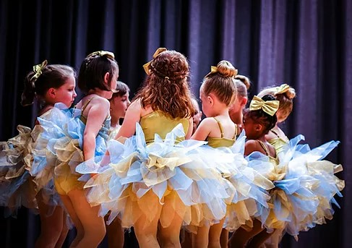

Coupon for You:
If your friend signs up you will receive $10 off one month’s tuition.

Coupon for your Friend:
Receive free registration, and $30 value!
Coupon expires 1/29/21
*New students only

Bring your friend to watch or take class with you!
January 18th – 22nd
Bring a Friend to Dance

Join Us Now!

Registration is still open!

Palmetto Dance Productions, LLC

Located downtown Rock Hill across from Fountain Park!
​
238 E. Black St.
Rock Hill, SC 29730
​
​
Phone: 803-984-5013 or 803-389-6226
Email: palmettodanceprod@gmail.com

Monday | Tuesday | Wednesday | Thursday | Friday/ Saturday
5-5:30  Petite Company Hip Hop | 5-5:45  3-4 Ballet/Tap Recreational | 5:15-6:00  Adult Beginner Dance | 5-5:45  6 & up Tap Recreational | By  Appointment/
5:30-6:30  Petite Company Jazz | 5:45-6:30  4-5 Ballet/Tap Recreational | 6:00 – 7:15  Petite Company | 5:45 – 6:30 Teen Tap | Special Classes/  Rehearsals
6:30 – 7:15  Petite Company Tap | 6:30- 7:30  6 & up Ballet/Jazz Recreational | 7:15 – 7:45  6 & up  Clogging | 6:30-7:15  Hip Hop
 | 7:30 – 8:15  Teen (11 & up) Lyrical/Jazz | 7:00-8:15  Teen Company | 7:15 – 8:15  Acro
7:45-8:45
Jr. Company
Updated Dance Class Schedule for 2021

